Project Executable Files

Date | 15 March 2026
Team ID | xxxxxx
Project Name | Credit Card Approval Prediction
Maximum Marks | 3 Marks

Project Executable Files
This section requires submission of all executable and deployable files for your project. Ensure all files are properly organized, named, and uploaded to the specified submission platform. The evaluator must be able to run or deploy your solution using the provided files and instructions.

Step 1: Submission Checklist

S.No | Item to Submit |  | Submitted  No / NA) | (Yes | /
1 | Complete source code (all files and folders) |  | Yes
2 | README / Setup Guide (instructions to run the project) |  | Yes
3 | requirements.txt / package.json / dependency file |  | Yes
4 | Database schema / seed files (if applicable) |  | NA
5 | Environment configuration file (.env.example similar) | or | Yes
6 | Deployed application URL (if hosted) |  | No
7 | APK / Executable binary (if applicable for mobile/desktop apps) |  | NA
8 | Dockerfile / Containerization config (if applicable) |  | NA
9 | Test files and test results |  | Yes
10 | Demo video or walkthrough (if required) |  | Yes

Step 2: File / Folder Structure
Provide an overview of your project's file and folder structure below:

Credit-Card-Approval-Prediction/
│
├── dataset/
│ ├── credit_card_data.csv
│
├── models/
│ ├── credit_card_model.pkl
│
├── app.py
├── train_model.py
├── predict.py
├── preprocessing.py
├── requirements.txt
├── README.md
├── .env.example
├── LICENSE
│
├── static/
│
├── templates/
│
└── screenshots/

Step 3: Deployment / Access Details

Field | Details
Hosted / Deployed URL | Not Deployed
Login Credentials  (Demo) | Not Required
Platform / Hosting  Provider | Local Machine
Repository Link | https://github.com/KRISHNAALEKHYA23/Creditcardapproval_prediction
Demo Video Link

Step 4: Run Instructions
Provide clear, step-by-step instructions for the evaluator to run your project locally:

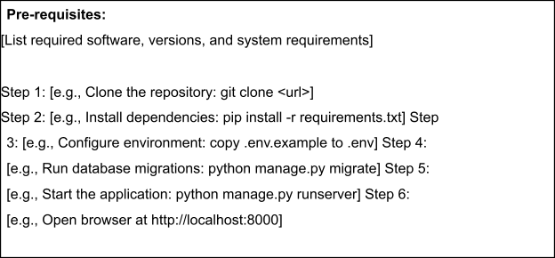

Step 5: Known Issues / Limitations

S.No | Known Issue / Limitation | Workaround / Status
1 | Application runs only on the local machine | Can be deployed to Streamlit Cloud, Render, or Azure in future
2 | No user authentication implemented | Planned for future enhancement
3 | No database integration for storing applicant records | Future enhancement using MySQL or MongoDB

